**How to Use Wchat**

Here's the welcome screen when you first start the app.

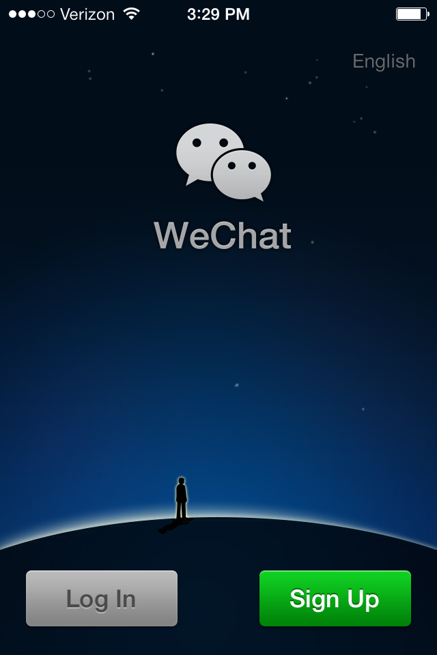

WeChat will ask you to put your cell phone number into the system.

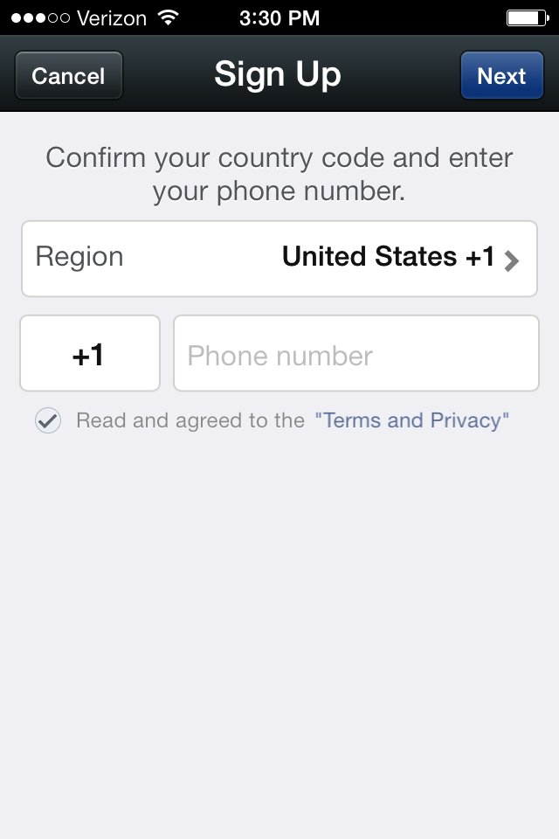

The program will text you a security code to type in. Your phone number will be posted at the top.

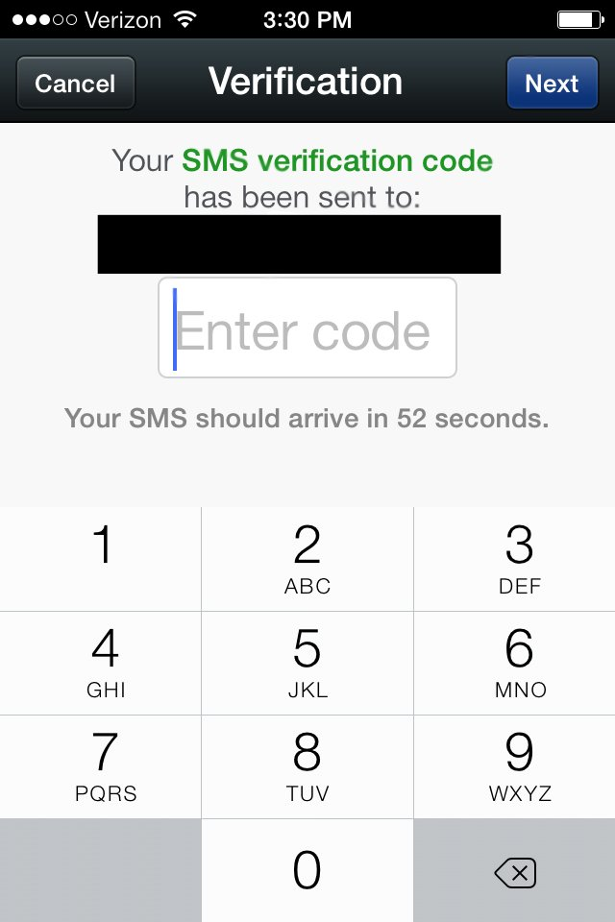

Upload a picture and create a WeChat ID to finish the setup process.

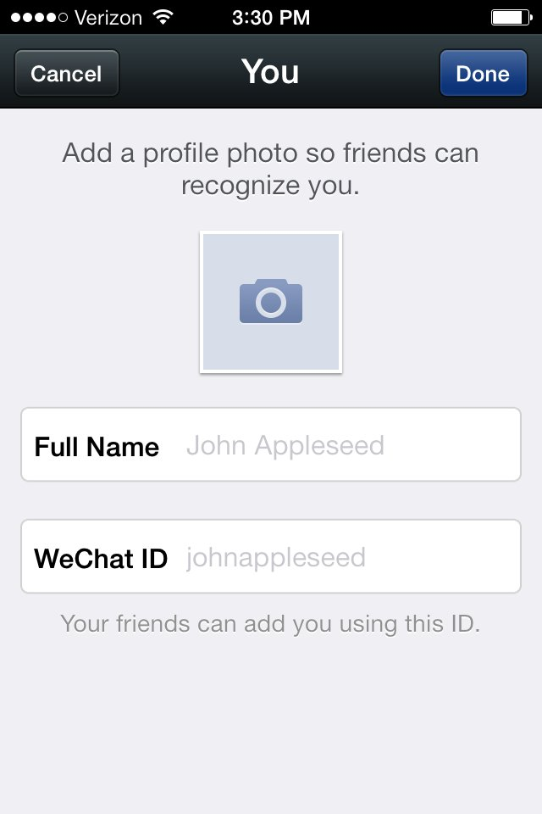

Make sure you fill out the essential information for your personal profile.

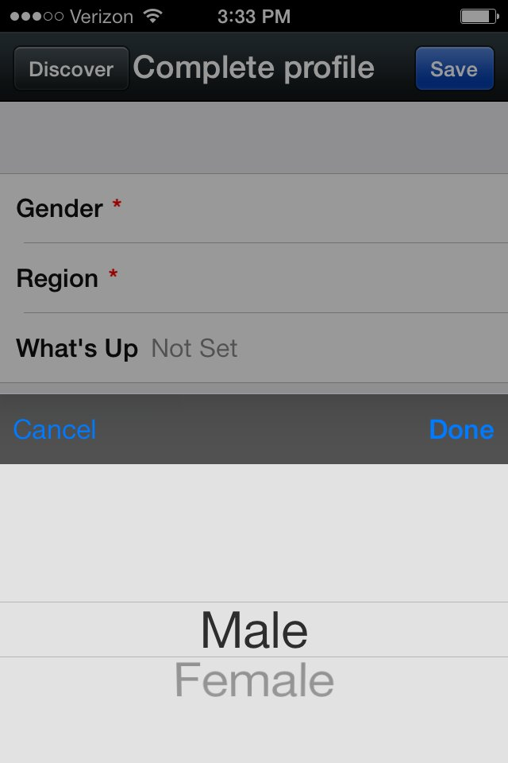

Profiles need specific location data. You can chat with people all over the world.

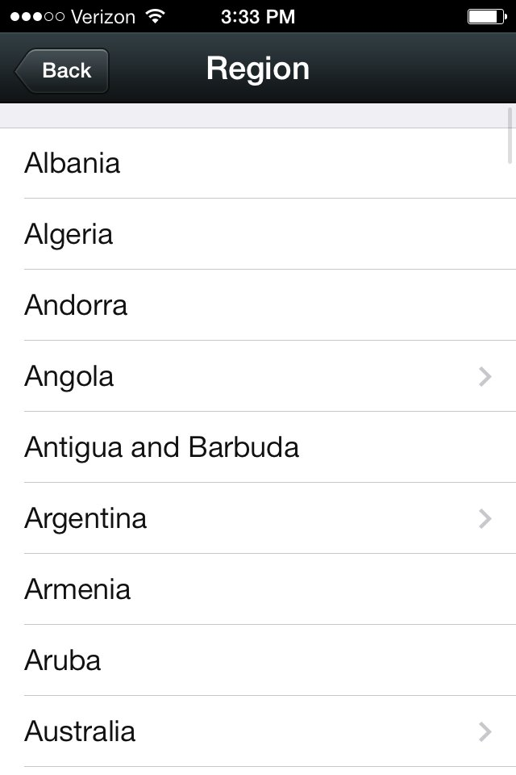

This is what your profile will look like after you finish it.

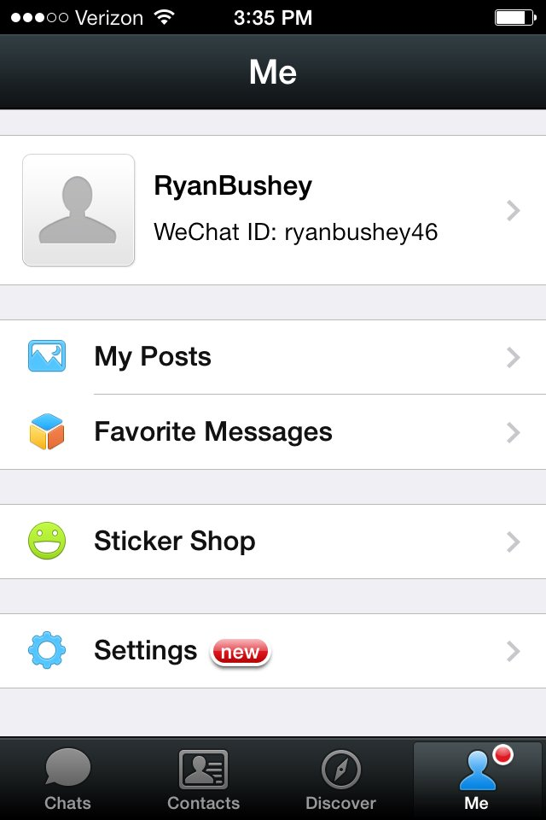

The app will search your list of phone numbers to quickly find friends who have WeChat.

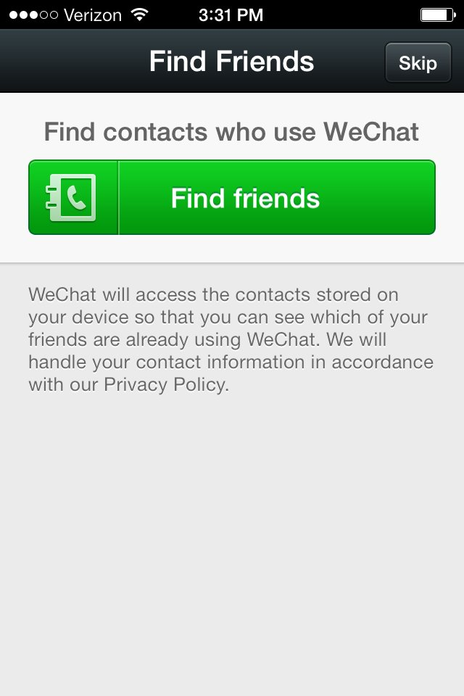**\*You can start talking with your friends by clicking the very left button *Chats*.**

**\*Once you hold, talk and release, the message will be sent out. It will not translate for you.**

**Additional Information**

Ways to add friends

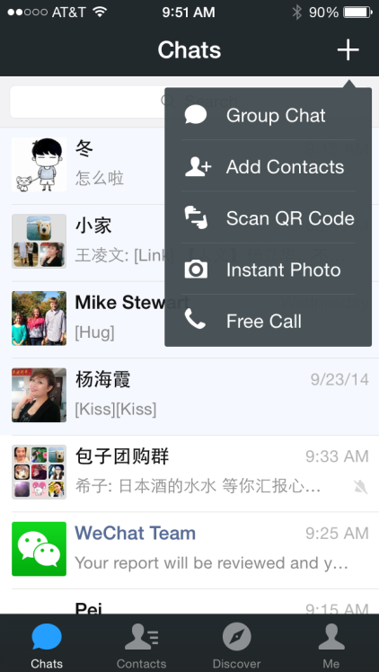1. Tab on the very right **+**, tab *Add Contacts.* You would be able to add friends from your mobile contacts or QQ contacts.

2. You can scan a QR code to start chatting with another WeChat user. Everyone gets a unique QR code.   
**How to find your QR code?** Tab *Me* (the very right tab), and tab your profile pic, go to *My QR code.*

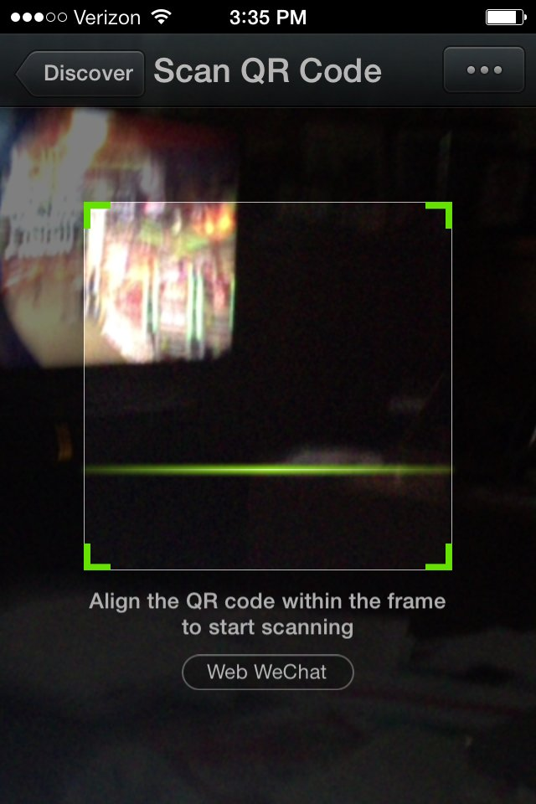

Group Chat:

Tab + , go to *Group Chat.*

Select the group you want to add to. You could change the group name, interact with friends.

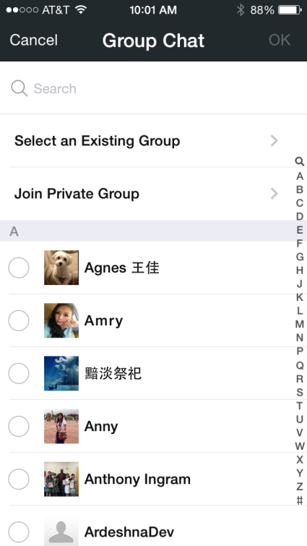

Moments:

Post moments to fill up your profile. You can add photo or text updates, just like you would on Facebook.



🡨Most Chinese students use this feature to show their lives, because it is not as public as FB, but still sharing with your friends around you. If you could engage with them by commenting on their moments, they would be really happy☺

Wechat Web Version:

Get too tired of talking? No problem. There is an online version. You could log in to any PC.

1. Go to <wx.qq.com>. You will see a QR code on the web.
2. Open your Wechat on your phone, and tab +, go to *Scan QR Code.*

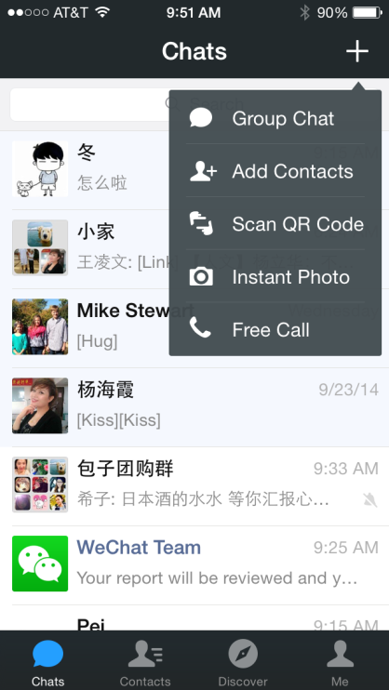

1. Scan the QR code on web.
2. Tab *Log in on Web*

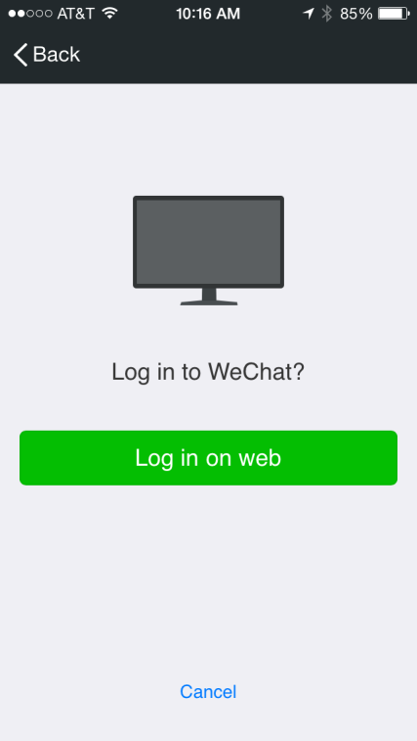

1. Now you can click on friends and type messages to them!

-For individual question, please contact Chinese Resource Network Team☺